Design and Development of an AI-Enabled Web-Based Eyewear Inventory and E-Commerce Management System (iWear) with an AI Business Insights Assistant
MSc Masters Project Specification
Supervisor: Tariq Alsboui Date: 17-Feb-2026

1. Abstract
The rapid advancement of digital technologies and e-commerce platforms has significantly transformed modern retail operations. Small and medium-sized enterprises (SMEs) increasingly rely on web-based systems to manage inventory, sales, and customer relationships. Despite this shift, many optical and eyewear retailers still depend on manual processes or basic spreadsheet-based solutions, which result in inefficiencies, data inaccuracies, poor stock control, and limited visibility of business performance.
This project proposes the design and development of an AI-enabled web-based Eyewear Inventory and E-Commerce Management System, named iWear. The system integrates inventory management, product catalog management, online ordering using a cash-on-delivery model, and eyewear-specific customization, including frame selection, lens options, and prescription data input. In addition, the system includes an AI Business Insights Assistant that allows store owners to retrieve business reports such as daily sales, profit, and best-selling products using natural-language queries.
The project will adopt an iterative and incremental development methodology encompassing requirements analysis, system design, implementation, testing, and evaluation. Modern web technologies will be employed to ensure scalability, usability, and security. The expected outcome is a functional prototype that demonstrates the effective application of computing and artificial intelligence techniques to address real-world challenges faced by eyewear retailers.
In addition to inventory management, the iWear system incorporates a customer-facing e-commerce module that supports eyewear-specific customisation, including frame selection, lens options, and prescription data input. Furthermore, the system integrates an AI Business Insights Assistant designed to provide store owners with accessible business intelligence through natural-language queries. Together, these components form a unified platform that supports operational efficiency, customer experience, and data-driven decision-making within the eyewear retail domain.

3. Justification and Overall Aim

3.1 Justification
Inventory inaccuracies are a persistent challenge for small and medium-sized retail businesses, particularly those operating with limited technical infrastructure. Many retailers continue to rely on manual stock updates or spreadsheet-based systems to manage inventory. While these approaches may appear simple and low-cost, they lack essential features such as validation, concurrency control, and real-time synchronisation. As a result, discrepancies frequently arise between recorded stock levels and actual physical inventory, leading to operational inefficiencies and financial losses.
In the eyewear retail domain, inventory management is significantly more complex than in standard retail environments. Eyewear products consist of multiple interdependent components, including frames, lenses, colours, brands, and prescription compatibility. Managing these variations without a structured and centralised system increases the likelihood of over-stocking, stock-outs, and incorrect order fulfilment. Such issues negatively affect customer satisfaction, delay order processing, and reduce overall business profitability.
Existing generic inventory management systems are typically designed for simple retail products and often fail to accommodate domain-specific constraints present in eyewear retail. Features such as frame–lens compatibility, prescription-based limitations, and variation-specific stock tracking are rarely supported in conventional systems. Consequently, eyewear retailers struggle to maintain accurate inventory records, particularly when operating across both physical stores and online sales channels.
Furthermore, the lack of integration between inventory systems and e-commerce platforms often results in outdated stock information being presented to customers. This disconnect can lead to orders being placed for unavailable products, increasing cancellation rates and damaging customer trust. For small optical retailers, such inefficiencies can have a disproportionate impact on business sustainability.
The justification for this individual project component lies in the need for a dedicated, database-driven inventory management solution that is tailored specifically to the operational requirements of eyewear retail. By implementing structured data models, real-time stock updates, and automated validation mechanisms within the iWear system, this component aims to reduce human error, improve inventory accuracy, and support more efficient stock control. The proposed solution addresses both operational and technical limitations present in existing approaches, offering a practical and scalable alternative for small and medium-sized optical retailers.

3.2 Overall Aim
The overall aim of this individual project component is to design, implement, and empirically evaluate a domain-specific inventory management module for eyewear retail that improves stock accuracy, ensures reliable concurrent transaction handling, and enhances operational efficiency for small and medium-sized optical retailers.

4. Objectives
The objectives of this project component are structured to support both system development and research-based evaluation:
- To analyse inventory management challenges specific to eyewear retail and identify measurable criteria for inventory accuracy and consistency.
- To design and implement a normalised relational database schema capable of modelling multi-attribute eyewear products and variation-specific stock levels.
- To implement CRUD-based inventory functionalities and evaluate their correctness through unit testing with defined validation benchmarks.
- To implement transactional stock update mechanisms and evaluate concurrency handling under simulated multi-user scenarios.
- To develop automated low-stock alert mechanisms and measure their responsiveness and accuracy against predefined threshold conditions.
- To evaluate the effectiveness of the proposed inventory module by comparing stock consistency before and after automated validation and transaction control implementation.

5. Literature Review
Inventory management systems are widely recognised as essential tools for improving retail efficiency, reducing operational costs, and supporting informed decision-making. Traditional inventory control approaches, such as manual stock keeping and spreadsheet-based tracking, are frequently associated with data inaccuracies and delayed reporting. While automated inventory systems offer real-time stock visibility and improved accuracy, their effectiveness varies depending on the retail domain in which they are applied.
Research by Heizer, Render and Munson (2020) highlights that real-time inventory visibility reduces stock-outs and excess inventory, contributing to improved supply chain performance. However, such studies primarily focus on general retail environments with relatively simple product structures. Generic inventory systems typically assume limited product variation and straightforward stock tracking mechanisms. While this model is sufficient for conventional retail goods, it does not adequately address specialised domains that require multi-attribute product configurations.
In eyewear retail, products consist of interdependent components such as frame type, lens type, prescription compatibility, brand, and colour variations. Generic systems often lack structured mechanisms for managing compatibility constraints or variation-specific stock tracking. This limitation increases the likelihood of stock inconsistencies and incorrect order fulfilment. Moreover, many generic inventory solutions emphasise operational efficiency but underemphasise domain-specific validation requirements.
Relational database architectures, particularly PostgreSQL-based systems, provide strong transactional integrity and concurrency control (Turban, Pollard and Wood, 2018). These strengths make them technically suitable for complex inventory environments. However, the literature reveals that while database technologies are robust, system design often fails to incorporate domain-specific modelling requirements. This disconnect between technological capability and domain-specific implementation represents a critical weakness in existing solutions.
Furthermore, SME-focused research indicates that enterprise-level ERP systems, although powerful, are often financially and technically inaccessible to small retailers. High implementation costs, configuration complexity, and required technical expertise limit adoption. As a result, SMEs frequently resort to simplified systems that lack proper concurrency control and validation mechanisms.

Research Gap
Although prior research demonstrates the benefits of automated inventory systems, limited attention has been given to domain-specific inventory modelling for specialised SME retail sectors such as eyewear. Existing systems either provide generic functionality without structured variation handling or offer enterprise-level solutions that are impractical for SMEs. There is therefore a clear research gap in designing and evaluating a lightweight, domain-specific inventory management module that integrates structured relational modelling, real-time transactional updates, and validation mechanisms tailored specifically to eyewear retail.
This project addresses that gap by designing and evaluating a specialised inventory module that aligns database integrity mechanisms with eyewear-specific operational requirements.

6. Methodology

An iterative and incremental development methodology is selected because it allows progressive validation of database design, transaction handling, and concurrency control mechanisms. Unlike linear development models, iterative development enables early detection of integration and data consistency issues, which are critical in inventory systems where transaction accuracy directly impacts operational reliability. This approach is therefore more suitable for evaluating system reliability and performance improvements within an academic timeframe.
An iterative and incremental development methodology is adopted for this individual project component. This approach is particularly suitable for system development projects, as it allows the inventory management module to be designed, implemented, and evaluated in progressive stages. By developing the system incrementally, functionality can be tested and refined continuously, reducing the risk of major design flaws and ensuring that the final solution aligns with operational requirements of eyewear retailers.
The iterative approach also supports flexibility, allowing design decisions to be revisited as new requirements or limitations emerge during development. This is especially important in the context of inventory management systems, where data consistency, accuracy, and system reliability are critical.

6.1 Data Design
A relational database design approach is used to model inventory data for the eyewear retail domain. The database schema is designed to store product details, stock quantities, and variation attributes such as frame type, brand, colour, lens options, and prescription compatibility. These entities are represented through structured tables with clearly defined relationships to support accurate data retrieval and manipulation.
Normalisation techniques are applied to minimise data redundancy and improve consistency. By separating product information, variation details, and stock records into distinct but related tables, the system reduces the likelihood of data duplication and inconsistency. Primary and foreign key constraints are used to enforce referential integrity, ensuring that all inventory records remain valid and consistent throughout system operation.
PostgreSQL is selected as the database management system due to its strong support for transactional integrity, concurrency control, and scalability. These features are essential for managing inventory data that may be accessed and updated simultaneously during order processing.

6.2 Inventory Module Development
The inventory management module is developed using Python with a web application framework such as Flask. Python is chosen due to its readability, extensive library support, and suitability for rapid application development. Flask provides a lightweight and flexible framework that supports modular development and easy integration with database systems.
Core inventory functionalities include the ability to create, update, retrieve, and delete product records. Authorised users can manage inventory items through secure interfaces, ensuring that stock information remains accurate and up to date. The system is designed to automatically update stock levels when sales orders are processed, reducing reliance on manual updates and minimising the risk of human error.
The module is implemented as a set of backend services that communicate with other system components through well-defined interfaces. This modular approach improves maintainability and supports future system extensions, such as advanced reporting or forecasting features.

6.3 Validation and Data Integrity
Validation mechanisms are implemented at both the application and database levels to ensure data accuracy and consistency. Input validation rules prevent invalid or incomplete data from being stored in the system, such as negative stock quantities or missing product attributes. These rules reduce the likelihood of data corruption and improve overall system reliability.
At the database level, constraints and transactional controls are applied to maintain data integrity. Database transactions ensure that inventory updates occur atomically, meaning that either all changes are successfully applied or none are applied in the event of an error. This is particularly important during concurrent operations, such as multiple sales being processed simultaneously.

6.4 Testing Strategy
A structured testing strategy is employed to evaluate the correctness, reliability, and performance of the inventory management module. Unit testing is used to verify the functionality of individual components, such as stock update logic and validation rules. These tests ensure that each function behaves as expected under normal conditions.
Integration testing is conducted to assess interactions between the inventory module and other system components, particularly order processing services. Test cases simulate realistic usage scenarios, including concurrent transactions and edge cases such as low-stock conditions. This approach helps identify potential issues related to data consistency and system stability.
Testing results are documented and analysed to determine whether the system meets its defined objectives and performance criteria.

6.5 Transaction Management and Concurrency Control
Concurrency control is a critical consideration in inventory management systems, as multiple users or processes may attempt to update stock records simultaneously. To address this challenge, database transaction mechanisms are implemented to ensure atomicity, consistency, isolation, and durability (ACID properties).
Transaction isolation levels are configured to prevent race conditions, ensuring that stock quantities remain accurate even during concurrent access. In the event of system failure or invalid operations, rollback mechanisms allow the database to revert to a consistent state. These practices significantly reduce the risk of inventory inconsistencies and align with best practices in database-driven application development.

6.6 Ethical and Practical Considerations
This inventory module does not store sensitive personal customer data. All stored information relates to products and stock levels. Access to inventory management functions is restricted through authentication and role-based access control to prevent unauthorised modifications.
Practical constraints, such as limited development time and academic scope, influence design decisions. As a result, the system focuses on core inventory functionality rather than advanced predictive features. These constraints are acknowledged and considered during evaluation.

6.7 Success Measurement Criteria
System success will be evaluated using measurable performance indicators, including:
- Inventory accuracy rate before and after validation implementation
- Successful execution of concurrent transactions without stock inconsistency
- Response time for inventory queries under simulated usage
- Accuracy of low-stock alert triggering against predefined thresholds
These criteria ensure that evaluation extends beyond functional implementation to include measurable performance and reliability benchmarks.

7. System Design
The system will follow a three-tier architecture consisting of:
- Presentation Layer: React-based frontend interface
- Application Layer: Python-based backend services
- Data Layer: PostgreSQL relational database

7.1 Module Descriptions
- Inventory Management Module: Manages products, stock updates, and low-stock alerts.
- Eyewear Customization Module: Handles frame selection, lens selection, and prescription entry.
- Order Management Module: Manages cart operations, order placement, and order history.
- AI Business Insights Module: Processes natural-language queries and generates business reports.

7.2 Security and Data Management
Security is a critical aspect of web-based systems. The proposed system will implement user authentication and role-based access control to restrict system access. Sensitive information such as user credentials will be securely stored using hashing techniques. Database access will be controlled through secure API endpoints to prevent unauthorized access.
Data integrity will be maintained through validation mechanisms and transaction management. Regular backups will be considered to minimize the risk of data loss.

8. Evaluation Strategy
The inventory module will be evaluated using the following criteria:
- Accuracy of stock level updates
- Response time for inventory queries
- Reliability during concurrent transactions
- Correct triggering of low-stock alerts
Evaluation results will be interpreted in relation to the defined project objectives to assess overall system effectiveness. Identified limitations will be documented to inform potential future improvements. This reflective evaluation approach ensures that both technical performance and practical applicability of the inventory module are considered.

9. Work Plan
This work plan illustrates the phased development of the inventory management module. The project begins with requirements analysis to identify eyewear-specific inventory challenges, including product variation and prescription dependency. A dedicated database design phase follows to ensure accurate modelling of frames, lenses, and stock quantities.
Core inventory functionalities, such as product creation and stock updates, are developed incrementally to allow early testing and refinement. Validation mechanisms and automated low-stock alerts are implemented to improve data integrity and operational efficiency. Integration tasks ensure that inventory levels are synchronised with order processing modules.
The final stages focus on systematic testing, evaluation, and documentation. This structured timeline ensures that the inventory module is robust, reliable, and aligned with real-world eyewear retail requirements.
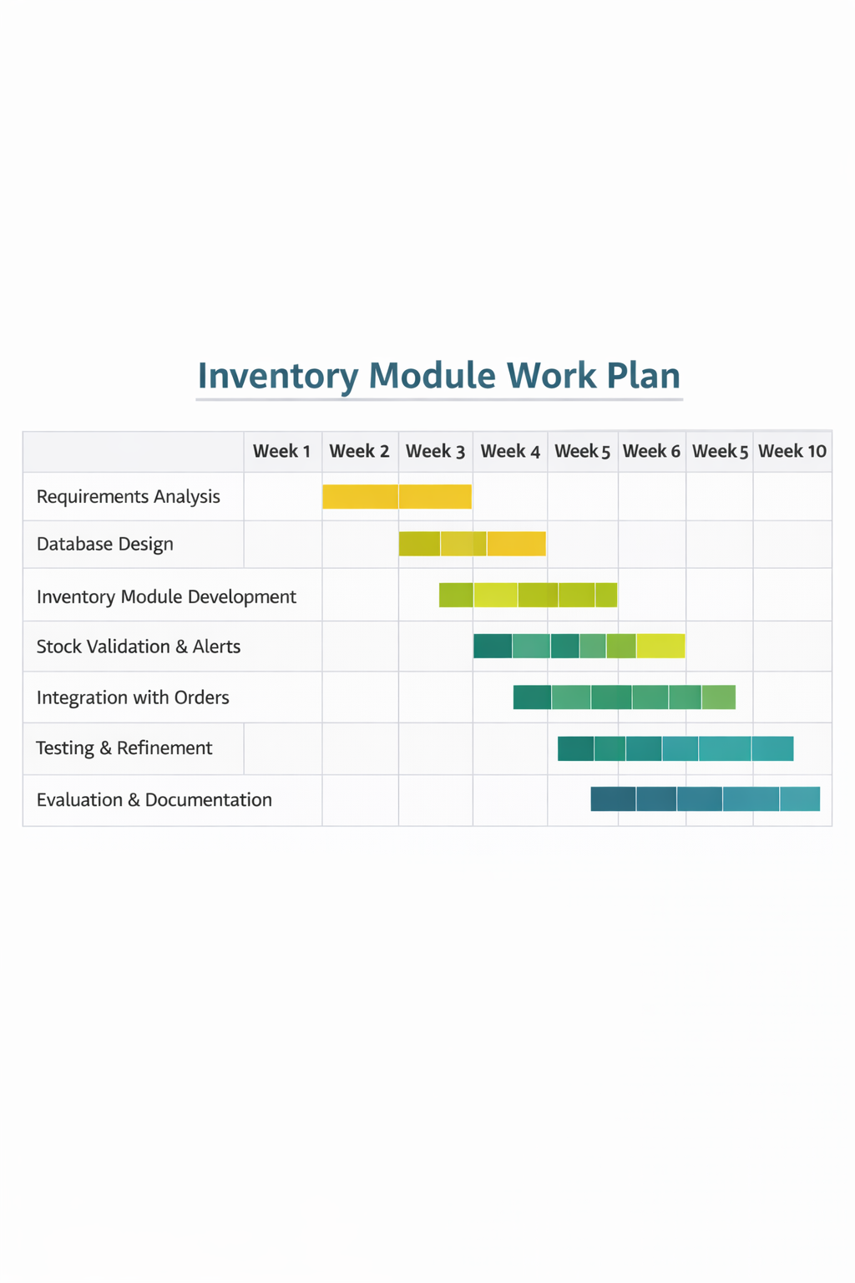

10. Ethical Considerations
The inventory module does not collect sensitive personal data. All stored data relates to products and stock levels. Secure authentication and role-based access control will be applied to prevent unauthorised inventory manipulation.

11. Risks and Limitations
Potential risks include incorrect data migration and concurrency issues during stock updates. These risks will be mitigated through validation checks and transaction management. The prototype focuses on core inventory functionality and does not include advanced demand forecasting features.

12. Conclusion
This individual component focuses on the development of a robust inventory management module for the iWear system. By addressing the complexities of eyewear products and stock variation, the module aims to improve inventory accuracy and operational efficiency for optical retailers.

References
Silver, E.A., Pyke, D.F. and Thomas, D.J. (2017) Inventory and Production Management in Supply Chains. 4th edn. Boca Raton: CRC Press.
Chaffey, D. (2019) Digital Business and E-Commerce Management. 7th edn. Harlow: Pearson Education.
Heizer, J., Render, B. and Munson, C. (2020) Operations Management: Sustainability and Supply Chain Management. 13th edn. Harlow: Pearson.
Laudon, K.C. and Traver, C.G. (2021) E-Commerce: Business, Technology, Society. 16th edn. Harlow: Pearson Education.
Turban, E., Pollard, C. and Wood, G. (2018) Information Technology for Management: On-Demand Strategies for Performance, Growth and Sustainability. 11th edn. Hoboken: Wiley.
Chen, H., Chiang, R.H.L. and Storey, V.C. (2012) ‘Business Intelligence and Analytics: From Big Data to Big Impact’, MIS Quarterly, 36(4), pp. 1165–1188.
Rouse, M. (2020) Inventory Management System. Available at: https://www.techtarget.com (Accessed: 15 January 2026).
PostgreSQL Global Development Group (2024) PostgreSQL Documentation. Available at: https://www.postgresql.org/docs/ (Accessed: 15 January 2026).
Flask Documentation (2024) Flask Web Framework. Available at: https://flask.palletsprojects.com (Accessed: 15 January 2026).
React Documentation (2024) React – A JavaScript Library for Building User Interfaces. Available at: https://react.dev (Accessed: 15 January 2026).

